**Usability testing**

**Description**

The primary goal of a usability test is to identify usability issues and gather feedback to make improvements and enhance the user experience of the certain design features that is implemented by IT1C requested from the client.

The represented client is Jan Doornbos, one of the five founders of Circle Solutions™.

The primary purpose of the website is to offer internet access to companies in different countries and regions. Customers should have the option to choose one of the 2 internet plans with different speeds, data limits, and pricing to suit their specific needs and budgets.

The website should also display clear pricing information, offer the website in multiple languages (English & Spanish) and include customer ratings of the internet service to build trust from the potential future users.

**Purpose of the test**

Usability testing helps identify problems or issues that users may encounter while interacting with a website. It provides insights into the overall user experience (UX) of the website, including factors such as ease of use, efficiency, and user satisfaction, which therefore are meant to help the developers on improving their website. Usability testing collects feedback directly from real users, allowing designers and developers to understand user preferences, expectations, and pain points.

This format of receiving feedback is going to test if there are any issues from a wide range, starting with navigation difficulties to confusing layout or content. Usability tests help confirm whether design decisions, such as layout, color schemes, and content placement, align with user needs and goals. It helps in ensuring that the design effectively communicates the intended message or functionality.

A user-friendly website leads to higher user satisfaction, increased engagement, and potentially better conversion rates, whether the site's goal is to sell products, provide information, or offer a service.

**Description of the test users**

Our Test users will be a group of students studying IT in NHL Stenden. This is a group of students who are at a similar level of knowledge of the IT1C group, learning the same concepts that the group is learning. This means they can give useful and accurate feedback. They also relate to the firms target audience which is IT companies as each person in the test group is aiming to acquire a job in this industry after their studies.

Diego’s review:

User1: Age 18, Department IT.

User2: Age 19, Department IT.

User3: Age 21, Department Marketing Management.

Erika’s reviews:

User1: Age 18, Department IT.

User2: Age 19, Department International Business.

User1: Age 21, Department Marketing Management.

User1: Age 21, Department IT.

Bill’s reviews:

User1: Age 27, Department IT.

User2: Age 21, Department IT.

User3: Age 25, Department IT.

Leon's reviews:

User1: Age 18, Department IT

User2: Age 18, Department IT

Artem’s review:

User1: Age 17, Department IT.

Mihael Druzeta reviews:

User1: Age 18, Department IT.

User2: Age 19, Department IT.

User3: Age 19, Department International Business.

Mihaela Covali reviews:

User1: Age 17, Department IT.

User2: Age 18, Department IT.

User3: Age 19, Department IT.

User4: Age 19, Department International Relationships.

User5: Age 19, Department Business and Administration.

User6: Age 19, Department Business and Administration.

User7: Age 19, Department Business and Administration.

User8: Age 19, Department Architecture.

User9: Age 22, Department General Medicine.

User10: Age 27, Department IT.

**Description of the test/survey**

In this study the team is going to test the user experience (UX) of their designs, to have feedback; The test will take place in NHL Stenden, Emmen. First the team will pick a test user, that will test the design of one team member going through all the pages and functionalities implemented, then right after the team will use a Survey Methodology with structured or open-ended questions used to have better understanding of what the team still have to implement and what is already user-friendly. The only software that team is going to use is Figma for showing the design, and send a Google questionnaire to ask the questions to the user.

The survey - <https://forms.gle/UVgeoWzAXBYYCmr36>

The storage of data in a usability test involves the emerge of quantitative and qualitative methods from the test-users. Besides they include a mark-up language, all of which would fulfil the product to satisfy clients. The outcome of this test may consist of several components that bring about insights for improving the usability of a product.

After the user completed the questionnaire, The team will analyze the qualitative feedback gathered from participants, their views during the website session and post-task survey.

**Questions&Responses:**

**Was something that you did not like?**

**no;**

**-;**

**nope;**

**Maybe to use the 4 font size rule and golden ratios,I recommend typescale as a good resource;**

**No, all was good;**

**I dont think so for now, but its always time for new updates;**

**Overall, i liked the site. There are no particularities about it that i dislike.;**

**nothing; I liked the site;**

**faq? ;**

**I think the font on some pages was really small No, there was not. ;**

**No , everything was perfect. ;**

**I have nothing to say. ;**

**The minor glitch with the theme switching on the light themed About us page ;**

**The pie cursor, most of the time I am not even sure if my click can really touch the button ;**

**no products prices included.**

**Do you want too add something?**

**No**

**-**

**Cool design**

**not really**

**I would like website to have romanian language 😊**

**Everything works fine like it is at the moment**

**no, it was great ;**

**Hm.. I think it's a good job!**

**Nothing really**

**FaQ**

**No, I do not.**

**I think it needs to have more information about the offers.**

**Its probably more of a personal preference so I didn't mention it earlier, but I feel like the words on the hero section of the home page could use a little more contrast. ;**

**On the services page, quality driven, user friendly and down-to-earth, thses three slogan are too catchy and big for my eyes to even ignore the most important information about what the company is doing for**

**no**

**Nope.**

**Did you expect something from the website that we didn't provide it with?**

**No**

**.**

**no**

**I think its a great website**

**-**

**Maybe more alternatives when choosing the language**

**Everything is brilliant!**

**Again no,the website provides with everything needed**

**no ;**

**No, the website provided all the information in order to understand what the company does, what are the services, how much it costs and how to contact the company for more details.**

**Nothing**

**Everything was provided**

**Yes**

**FaQ and prices**

**I don't think so**

**No. Its actually fine and easy to understand the mobile app. In addition, it didnt require me to click to much to see the information that i need. So its a good application if you ask me. ; No.**

**Some key words for navigation can be more obvious and bigger**

**it's good how it is.**

**From the next page, the statistics from the from are going to be displayed.**

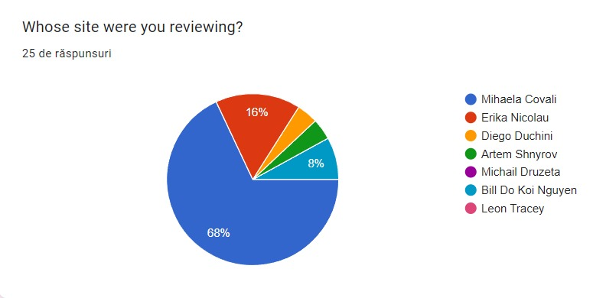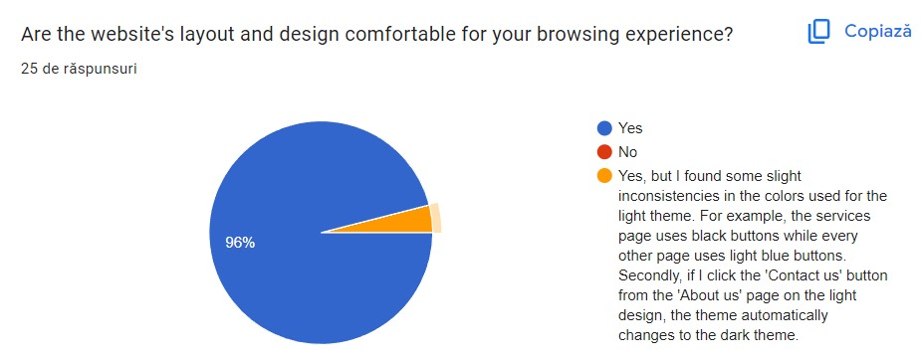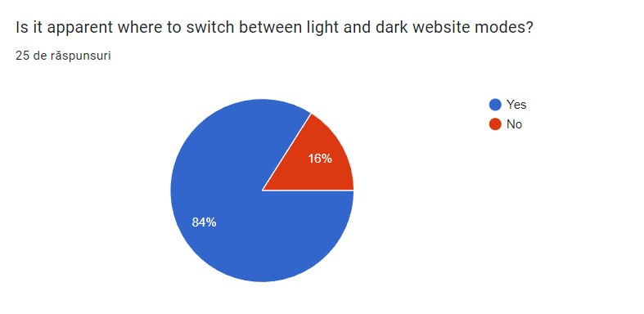

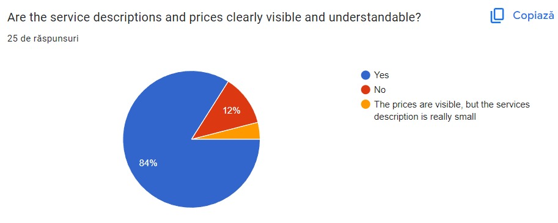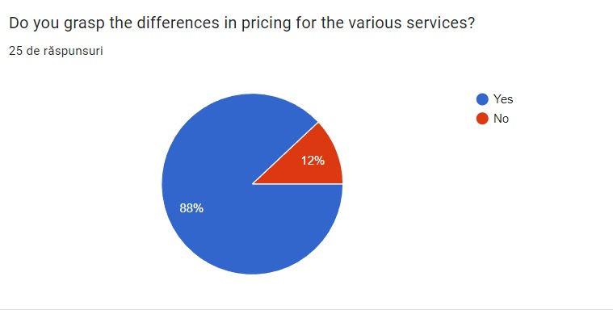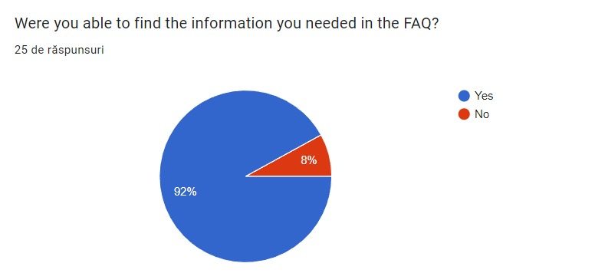

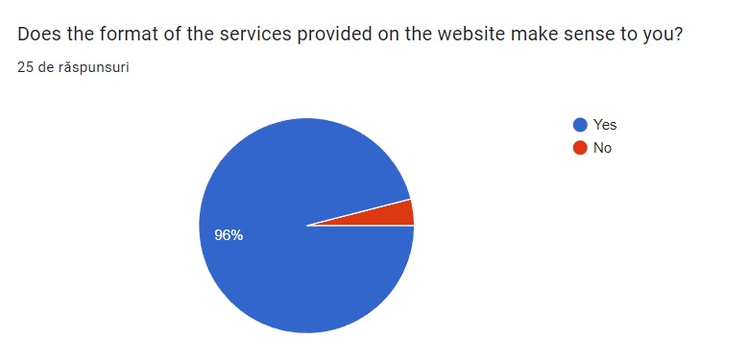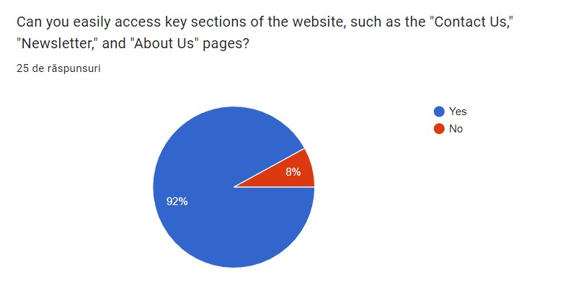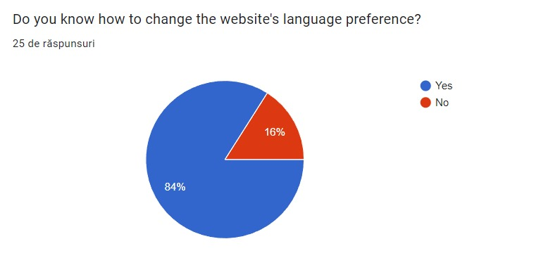

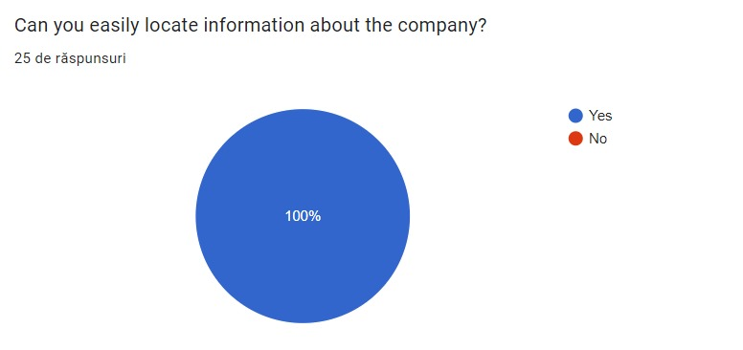

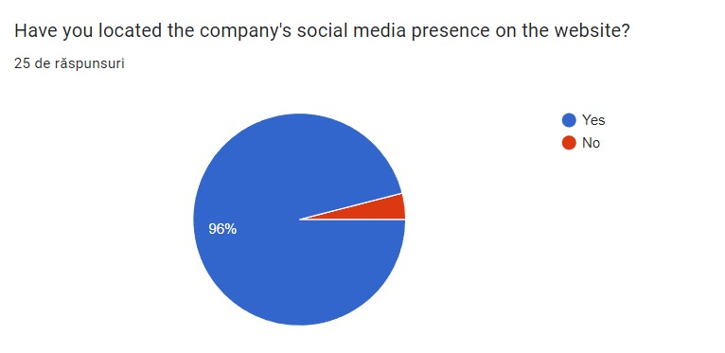

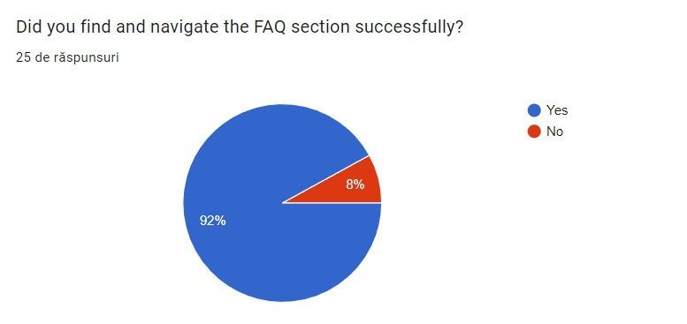

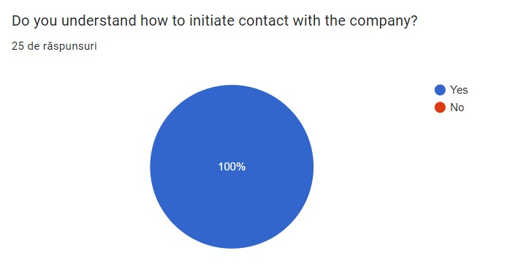

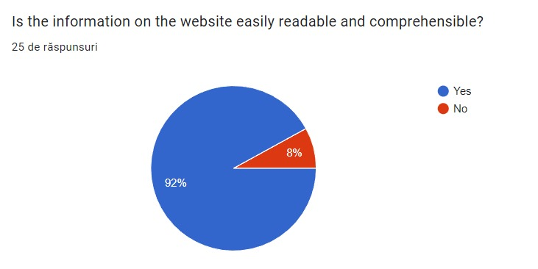

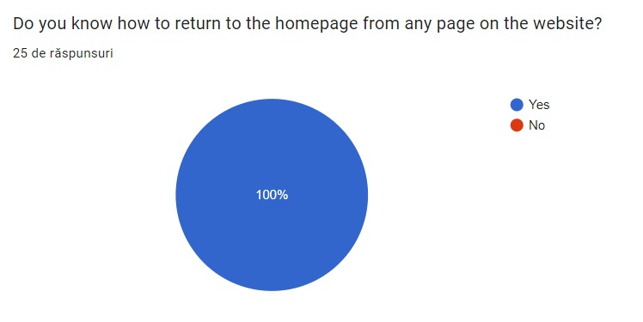

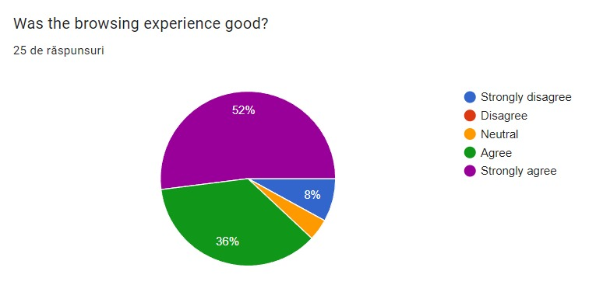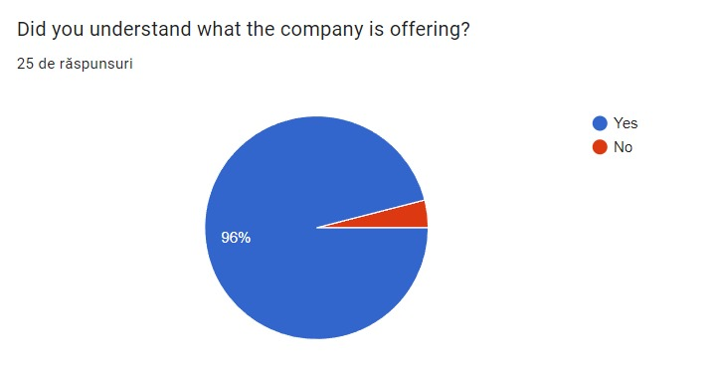

**Conclusion**

The feedback from the users showed satisfaction and understanding of the group designs, in fact for most of the designs the requirements were attained such as: the website's layout and design, the accessibility of the main Pages (Newsletter, About Us, Contact Us), the visibility and understanding of the descriptions, the clearance of what the company is offering, the language preference option, to easily find the FAQ section.

Overall, there was no need for improvements for the final design, the group believes that the implementations were satisfactory and on point.

**Recommendation for improvements**

Design is an iterative process, and ongoing feedback and improvement are key to creating a successful user experience. After careful consideration and evaluation, we've determined that the current design aligns with our goals and meets the needs of our user base effectively. While we value the suggestions received, we believe that the existing design provides an optimal user experience and addresses the requirements of our target audience.

Through the form we have created, we have analyzed the responses and have understood that we need to put more attention on our page structure, choosing the right proportions of the buttons and of the elements, in that way we provide more clarity in the information presented. In addition, people suggested to implement more international languages, but after the discussion with our client, we summarized the need being just upon English and Spanish.

We continuously monitor user feedback and conduct regular assessments to ensure our design remains up-to-date and user-friendly.

By implementing these recommendations and staying attuned to user needs, we can enhance our design and satisfy our user base.